

Year 6 Optional Topic Homework- Autumn Term
World War 2; Animals including humans, living things and their habitats
Activities linked to our topic
History:  Make a (model!) air raid shelter. / Anderson shelter. Think about which materials would be best to use.  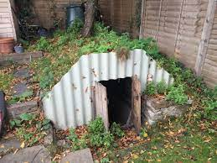 | History:  Research rationing and write a menu using those ingredients.  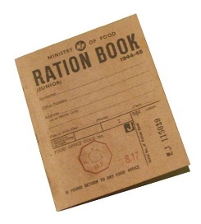 | History:  Design a parachute for a soldier that would keep it safe.  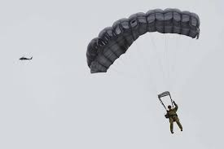
History:  Find out what the Enigma machine did and where it was based.  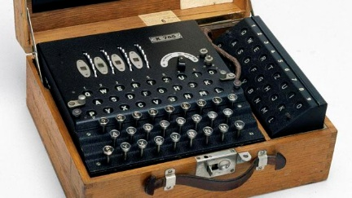 | Science:  How does the heart work? Present your findings in an interesting way.  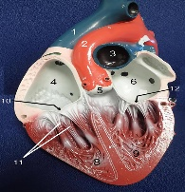  This Photo by Unknown Author is licensed under CC BY-SA-NC | Science:  What living things can you find in your garden or outdoor space near your home?  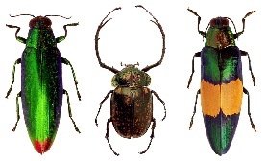
Geography:  Find some old maps or aerial photos of Letchworth online. How has it changed over the years. Why do you think this is?  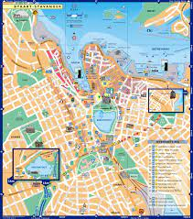 | Geography:  After World War 2, the population of many parts of Britain changed. Can you find out how and why?  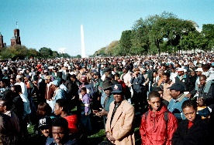 | Art:  Create a self-portrait using your favourite media.  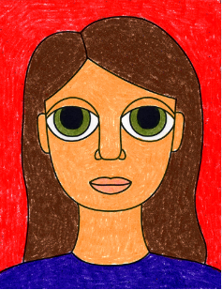
Books linked to our topic
