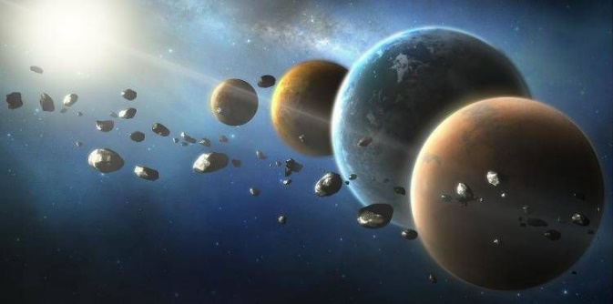

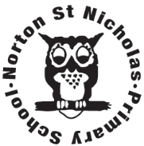
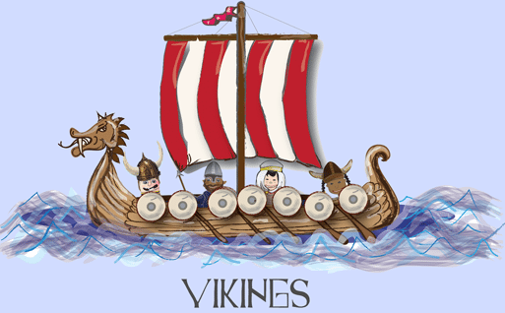Year 5 Optional Topic Homework
Autumn 2026
Vikings/Earth, Sun and Moon

Activities linked to our topic
The Viking invaders travelled to and from Britain in longboats. Research how Viking longboats were constructed and any other information that you can find out about them. You could build your own model to demonstrate. | Design and make a helmet- we will explore the myths and realities of Viking helmets, but can you make your own?  Make sure you are battle ready! | Persuasive Travel Brochure: Design a leaflet persuading Viking families from Scandinavia to migrate and settle in Danelaw (York/Jorvik). Include sections on farming, trade, and land availability.
The moon does not always appear the same shape. Carry out a ‘moon watch’ over a month. Can you record how the moon appears to change shape over time? You could take a photograph at the same time each night. | It is 52 Years since Neil Armstrong became the first man to walk on the moon on Apollo 11. Research the Apollo Moon landings and present your work in an interesting way. | Create a map or model of the solar system showing each of the planets and its position compared to the sun.
Books linked to our topic
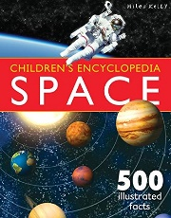
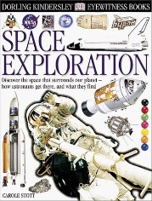
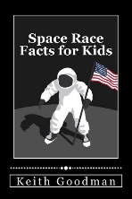
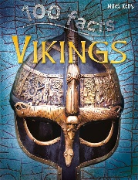
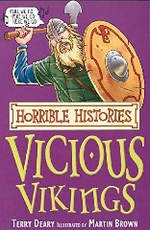
Horrible Histories – Vicious Vikings
100 Facts Vikings – Miles Kelly
Space Race Facts for Kids – Keith Goodman
Dorling Kindersley Eyewitness Space Exploration
Space: A children’s Encyclopedia

