
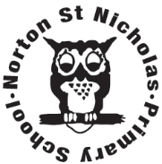
Year 4 Optional Topic Homework Autumn 2026/27
Science: States of Matter Geography: Rivers History: Ancient Egypt
Activities linked to our topic
Science States of Matter: can you create a word search for the vocabulary that we use in the States of Matter Science topic? Use the words below:  Solid, liquid, gas, spread, cut, pour, volume, space, invisible, squash, heat, cool, melt, freeze, evaporation, condensation, water cycle, temperature. | Science States of Matter: Go on a SOLIDS, LIQUIDS AND GAS hunt around your home. Record the solids, liquids and gases that you find in a table like this one: | DT & Science, heating & cooling materials:  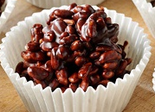  Make a chocolate crispy cake to investigate what happens when you heat, then cool chocolate.  You can use your own recipe or the one attached.
  SOLIDS | LIQUIDS | GASES
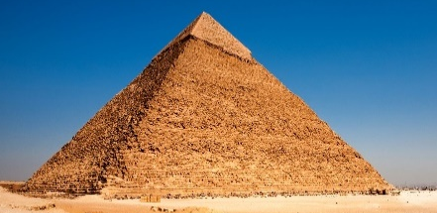  History: Find out more about the construction of the pyramids. Which materials would be best for pyramid building? Can you build a pyramid at home using Lego or things from around the house? | Maths: The Ancient Egyptians had their own number system. Can you use it to write out some number sentences?  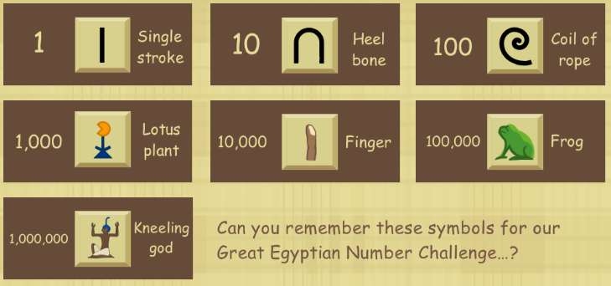  https://www.childrensuniversity.manchester.ac.uk/learning-activities/history/ancient-egypt/the-egyptian-number-system/ | 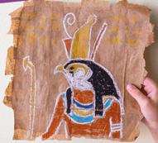  Art and Design: Make your own papyrus and decorate with an Egyptian image.  https://letsgolivescience.com/activity/diy-papyrus-paper/
Geography: Write a fact file about a river in another part of the world; it could be the Nile, the Yangtze or the Thames.  Where is it found? Draw a map to illustrate.  How long is it?  What is the river course?  Any interesting facts about this river? | 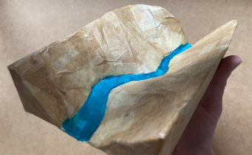  Geography: Make a 3D river  See Darrell Wakelam’s cardboard 3D river video.  https://www.darrellwakelam.com/news/cardboard-box-river | 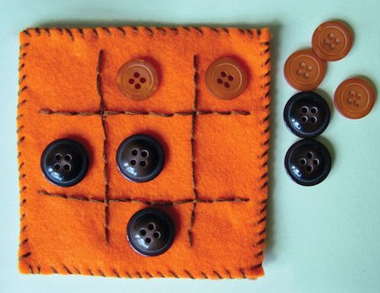  DT: Textiles & Sewing  Explore different sewing techniques to join two materials together such as running stitch or overstitch.
Books linked to our topic
Get into Science: Solid Liquid or Gas? by Jane Lacey; Water Cycles by DK; Water Wow! By Antonia Banyard and Paula Ayer; Why is Ice Slippery? by Anna Claybourne
Once Upon a Raindrop: The Story of Water by James Carter; Great Rivers of the World, Volker Mehnert; Horrible Geography Raging Rivers; Rivers, Peter Goes; Journey to the Sea, Eva Ibbotson; Song of the Dolphin Boy, Elizabeth Laird
Mummies Unwrapped by Tom Froese; Ancient Egypt: Tales of Gods and Pharaohs by Marcia Williams; Great Lives in Graphics: Secret Treasures of Ancient Egypt by Kate Sparrow; Cleopatra by Books Button; Tough Times: A Kid’s Life in Ancient Egypt by Roger Canavan; You Wouldn’t Want to be a Tutankhamun by David Stewart.

Name: _________________________

Science Vocabulary Word Search: States of Matter
