

Year 2 Optional Topic Homework Autumn 2026
Our wonderful world (Geography) and Animals including Humans (Science)
Activities linked to our topic
Art  Create a piece of art in the style of Yayou Kusama. You could use pencils, paints or even the computer!  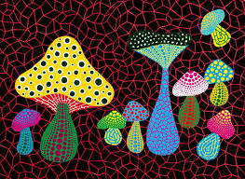 | English  Choose one of the continents or countries we have been learning about. Make a fact file all about it You could present this as a book, a poster or a PowerPoint presentation.  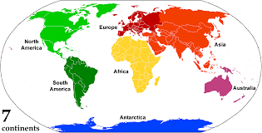 | Science  Animals have basic needs for survival. Research how to look after a pet to keep it healthy.  What does it eat? How much does it drink?  Where does it sleep? Does it need any exercise?  How do you keep it healthy?  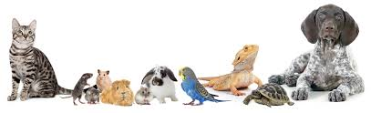
Geography  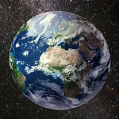  Show us why you think our world Is wonderful! What In our world fascinates you? You could draw a picture, make a collage, create a poster or do a presentation to show us | Science  Make a list of animals and the names of their babies (offspring) e.g. Elephant and calf. Then illustrate your list.  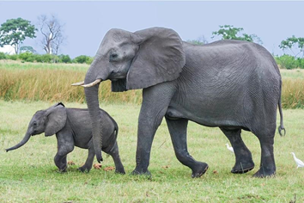 | Science  Make a food diary for the week to see which different types of food you eat. A copy of the journal can be found on the back of this sheet.  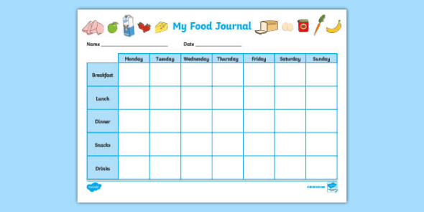
Books linked to our topic (these are just a few examples!)
The Couch Potato by Jory John & Pete Oswald;
Hello World: Animals: An Amazing Atlas of Wildlife by Nicola Edwards and illustrated by L’atelier Carographik;
Lonely Planet Kids Bug Atlas by Joe Fullman;
Marvellous Body by Jane Wilsher & Andrews Lozano;
Cat Eyes and Dog Whistles The Five Seven Senses of Humans and other Animals by Cathy Evans and illustrated by Becky Thorns;
I Do It Like this by Susie Brooks and Cally Johnson-Isaacs;
The wonderful world by Katie Petty and Jennie Maizels, Britannica kids atlas, Usborne- questions and answers about our world.

