

Year 1 Optional Topic Homework
Animals Including Humans!
Activities linked to our topic
Use those senses and go on a senses hunt. I wonder if there is something that you can use all 5 senses on…  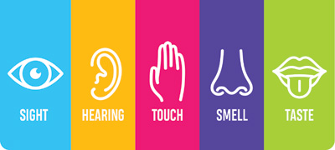 | Tell us all about your favourite animal! What does it look like? What features does it have? What groups does it belong in?  You could share this information in a poster or a book or in a video.  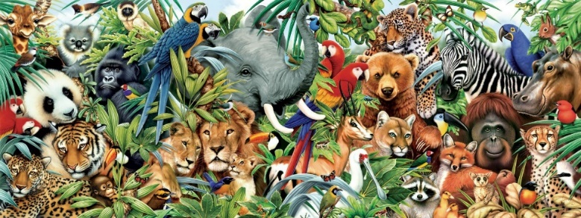 | Become familiar with a key board on a laptop or computer. Have a go at typing up some sentences about you. What would you like us to know about you? Don’t forget to use the space bar between words!  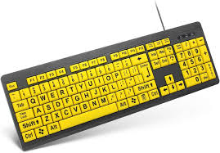
Draw an animal using a variety of different media (pencils, crayons, pens, chalk). Which did you like using the most? Why?  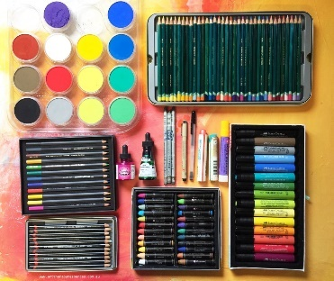 | Design and make your own 3D animal to go on Mrs Dunk’s shelf. Think carefully about the colours, size and shape.  Here are a few examples of what you could make it out of:  Lego  Playdough  Junk e.g. toilet roll tubes and milk cartons | These are fun maths games to play!  https://www.topmarks.co.uk/learning-to-count/teddy-numbers  https://www.topmarks.co.uk/learning-to-count/ladybird-spots
Books linked to our topic (these are just a few examples!)
Habitats and Food Chains by Fundamental Science KS1
Wings, Paws, Scales and Claws by Fundamental Science KS1
You Can’t Take an Elephant on a Bus by Patricia Cleveland- Peck
Funny Bones by Janet and Allan Ahlberg
Arrrggghh Spider by Julia Donaldson

